Climate Emergency Unit/Progress Report
Speaking Points/Background
Summary Points
- The Climate Emergency Open Letter came out in 2021 with 200 signatory organizations; NDP signed onto the Letter in 2023; today, 640+ orgs representing ~2.2M people. “83% of Canadians believe climate change is happening and that governments should act.” Abacus Data poll, Oct25.
- This year’s Climate Emergency Progress Report has 8 of 10 failing grades; worst since Report started in 2022. The 10 Grades are: set binding, informed, targets (fail); invest in a thriving, regenerative, zero emissions economy (fail); rapidly wind down all fossil fuel production and use (fail); end fossil fuel subsidies and make polluters pay (fail); leave no one behind (fail); protect and restore nature (fail); invest in local, organic, regenerative agriculture and food systems (fail); accelerate the transition to zero emission transportation (minor progress); accelerate the transition to zero emission buildings (minor progress); track and report progress on these actions every year (fail).
- Key takeaways: climate damages ~$17billion/year; approved LNG projects will rep 1/3 of BC’s total emissions (the world needs to cut emissions by nearly half this decade); greenwash LNG through electrification; weakened nature protections and fast-tracking industrial development; need to renew CleanBC with policies to meet our ambitious targets; build for future, not past – climate action reduces energy and transportation costs, creates jobs, builds healthier communities, improves energy security.
- BC is no longer a climate leader; ‘Elbows up’ against the US and aligning with Canada’s ‘major projects’ approach; The less than $1B projected annual LNG revenues is less than BC receives from Lotto or from BC Liquor Stores taxing annually.
- Solutions – BC should tax the super-rich and big polluters (polluter pay principle), increase royalty rates for fossil fuels and water, and end fossil fuel subsidies.
- Stop approving new fossil fuel infrastructure (Fracking; BC is late to the party LNG will soon experience a ‘glut’; Shell and Petronas are selling their stakes in LNG Canada; ‘stranded assets’ going forward; LNG is a bad bet that locks BC into yesterday's energy while competitors rapidly build the future (BCs NDP has a love affair with LNG. The economics say its time to break up; 8 Site C dams); Invest in public transit and active transportation; Reallocate infrastructure funds from highway expansion to public transit and active transportation; Invest in heat pumps and energy retrofits; and Invest in ecosystem restoration.
- NOTE TO SELF – explore ‘two energy sources’ – LNG: frack (water) transport produce (8 Site C dams) ship (tanker spills) profit to billionaires high risk, versus Renewables: local supply chains decentralized in communities across BC, with (many more) jobs and revenues supporting local economies and battery storage feeding provincial grid (more sustainable, more healthy, more climate-aligned, and less risky economically).
- Questions for MLA:
  - Could you help us understand what internal government pressures are leading to this rampant fossil fuel expansion?
  - Are your Cabinet colleagues aware of the risks that come with BC’s LNG expansion? (i.e. health risks, lack of jobs, rising electricity bills, greenwashing LNG, increased pollution)
  - Are opportunities coming up for us to support the BC gov’t in bringing in bolder action?
  - Could you agree to take this Progress Report to your colleagues in caucus (or a question that feels more fitting, given the topic and your MLA)?
+++++++++++++++++++++++++++++++++++++++++++++++++
Four Discussion Themes for Synthesis

- The Climate Emergency Open Letter and Progress Report
  - Open letter in 2021 had 200 organizations sign on
  - The BC NDP signed on in 2023
  - Today/2025, the Letter has 640+ org’s signed on, representing ~2.2M BCers
- This is the worst grade for Government to-date – 8 out of 10 ‘fails’
  - This is consistent with the lack of commitment to, and funding for, climate action (incl 2026 Budget Speech)
- What are the recent views/reasoning from the NDP on stepping away from climate action?
  - internal dynamics/pressures within gov’t ‘fueling’ fossil fuel expansion (revenue)?
  - opportunities to support BC government in bolder climate action?
  - can you agree to take this topic to your colleagues in caucus?
- To what extent are the NDP aware of the risks of BC’s LNG expansion?
  - overall, inability to meet BC’s GHG reduction targets?
  - health risks, particularly for residents of Kitimat; residential stove tops
  - loss of good paying skilled jobs in communities across BC
  - rising electricity bills, particularly with a new multi-billion plan to build grid to Kitimat (and the need to build some 8 Site C dams)
  - perpetuating LNGs longstanding disinformation/greenwashing campaign, building for the past, compromising the future

+++++++++++++++++++++++++++++++++++++++++++++++++

We suggest you share the following):
- The overall grades (pg. 14-15 of the report). Note that these are the worst grades given since the reports started in 2022)
- Key takeaways (pg. 7)
- “Ways to finance climate solutions” (pg. 8)

645+ organizations and businesses from diverse sectors have signed on to these 10 urgent climate actions, representing 2.2 million British Columbians. People in BC still care about climate change, even if other issues are currently taking precedent.

[TIP: If you are meeting to discuss a specific action, focus on the grade assigned to that action, sharing the detailed data from experts on each action, explaining why it received the grade it did.]

Questions for MLA:
- Can you tell us about any internal dynamics or pressures within government that are leading to this rampant fossil fuel expansion?
- Are you aware of the risks that come with BC’s LNG expansion? (i.e. health risks, lack of jobs, rising electricity bills, greenwashing LNG, increased pollution)
- What opportunities are coming up where we can support the BC government in bringing in bolder climate action?
- Can you agree to take this topic to your colleagues in caucus? (or a question that feels more fitting, given the topic and your MLA)

Common talking points we hear from MLAs, and how to respond

BC is broke. This is a period of austerity. We aren’t able to fund climate solutions.

There are a number of ways the government could fund climate solutions, including:
- taxing the ultra wealthy
- taxing big polluters
- increasing royalty rates for fossil fuels and water
- ending fossil fuel subsidies

If this is truly a period of austerity, the BC government should not be handing out millions to fossil fuel companies. This is not a question of whether the money exists, it is a question of whether the government wants to continue subsidizing the companies fueling the flames of climate chaos or fund climate solutions.

British Columbians aren’t concerned about climate change anymore. We have to focus on other priorities.

That’s why I am here. I am a constituent who is concerned about the climate. The BC Climate Emergency Campaign has 645+ organizational signatories representing 2.2 million British Columbians. I know that British Columbians are struggling with many pressing issues like housing, affordability, and healthcare. But these issues are interconnected. Many of the causes and solutions to these issues are the same as the causes and solutions to the climate crisis.

For example, BC could make heat pumps free and incentivize energy retrofits for buildings. Pass legislation to stop new gas hookups in buildings. This will reduce pollution, save lives, and improve affordability by lowering energy bills.

Abacus Data polling shows 75% of Canadians are concerned about climate change (see below).

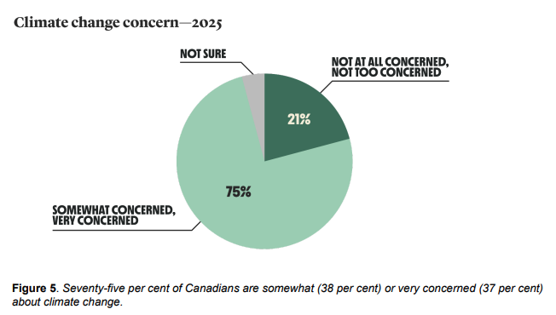
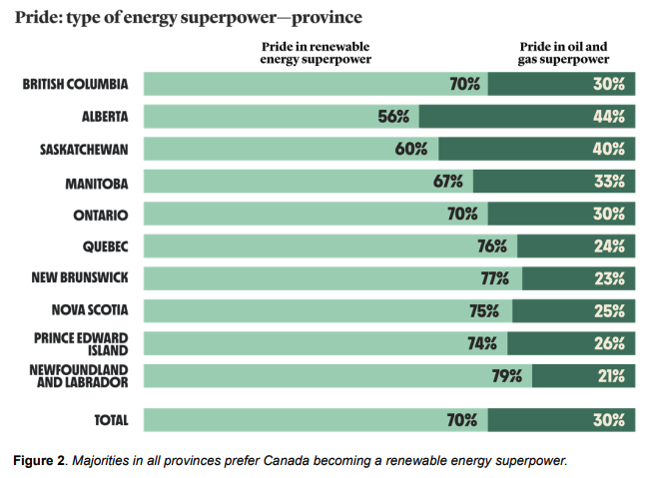
Also, 70% of British Columbians - a clear majority - would prefer Canada to be a renewable energy superpower, rather than an oil and gas superpower.

BC’s LNG is the cleanest in the world.

LNG is a fossil fuel. Even if it’s claimed to be “low-carbon” because the liquefaction process is fueled through electrification, the entire life cycle of LNG (fracking, transport, regasification, combustion) must be taken into account. Methane leaks at every point along the life cycle, and is a potent fossil fuel, over 80 times more potent than CO₂ over 20 years.

Even if BC’s LNG is supposedly “60% lower than the global average,” that’s still millions of tons of pollution entering the atmosphere.

Other countries, like India and China, need BC’s LNG to get off coal.

This is a myth. Studies show that LNG is not displacing coal, but crowding out and delaying renewable energy buildout.

When considering the entire lifecycle of LNG, including methane leaks, LNG is actually as bad as coal, or worse.

BC’s LNG projects are Indigenous-led, and will help these communities prosper.
While some First Nations have partnered with LNG projects, many First Nation leaders oppose them due to environmental risks, impacts on rights and title, and threats to salmon and traditional territories.

True economic reconciliation means investing in Indigenous-led clean energy, not locking communities into fossil fuel infrastructure destined to become stranded assets as the world transitions quickly to clean energy.

More LNG-related talking points

Economic Concerns: Why LNG is a Risky Investment for BC

1. Global LNG Demand Is Not Strong Enough to Justify Massive Investments
- global demand for LNG plateauing; potentially oversupplied by the end of decade,
🚩A big red flag: Shell and Petronas are selling their stakes in LNG Canada https://todayinbc.com/2026/01/23/potential-lng-canada-ownership-shift-raises-questions-about-phase-2-of-b-c-project/

2. BC’s LNG Projects Are Likely to Be Uncompetitive Globally
The Turning Tides report finds that LNG projects in BC are less cost-competitive than producers in Qatar, the U.S., and Mozambique, meaning British Columbia may struggle to secure market share.

3. LNG Infrastructure Will Become “Stranded Assets”
Large, capital-intensive LNG facilities with long payback periods face significant risk of becoming under-utilized or unprofitable if global energy markets shift faster toward renewables or if demand stagnates.
Busting the business case for LNG in BC
https://carbontracker.org/reports/turning-tides/?utm_source=business%20in%20vancouver&utm_campaign=business%20in%20vancouver%3A%20outbound&utm_medium=referral
Excellent webinar talking through the report: How Oil & Gas Companies Respond to Shrinking Markets - Turning Tides
Quotes from Werner Antweiler, associate professor and chair of both the Strategy and Business Economics Division and International Trade Policy at the UBC Sauder School of Business:
“The LNG market is thinning out and is oversupplied over the next few years.” “Even if a project goes ahead, it could still falter when the investors aren’t coughing up the money to proceed.” “The margins of exporting to Asia aren’t very large.” “There is an increasing sense that we are heading into an LNG glut… I don’t see LNG Canada Phase 2 going ahead at this point.”
Source:https://todayinbc.com/2026/01/23/potential-lng-canada-ownership-shift-raises-questions-about-phase-2-of-b-c-project/

-Visit this site! New excellent resource launched Feb, 2026: https://weareadamant.ca/ - e.g., BCs NDP has a love affair with LNG. The economics say its time to break up: "The NDP is betting billions on an industry in decline, while clean innovation goes unfunded. British Columbians deserve better. The economics are clear. LNG is a bad bet that locks BC into yesterday's energy while competitors rapidly build the future."

4. Domestic Energy Costs Will Rise
- Similar LNG export models internationally (e.g., U.S., Australia) have been linked with higher domestic natural gas prices, increasing heating and energy costs for residents.
- Electricity bills are also poised to increase because the BC government wants to use clean electricity to power LNG export facilities, which could also result in a new multi-billion dollar public subsidy to greenwash fossil fuels. The capacity required exceeds the amount of electricity currently available, and the additional generation capacity that would be needed to be built out is equivalent to eight Site C projects. The Site C hydroelectric dam is the most expensive public infrastructure project in Canada.
- “Will Minister Dix tell BC residents that they need to compete with the LNG export industry for energy to heat their homes and that their electricity and gas bills are going to go up?”- Tracey Saxby

Climate and Environmental Impacts

5. LNG Is Not a Climate “Bridge Fuel”
- LNG is overwhelmingly methane (liquefied natural gas), and methane is a potent greenhouse gas: over 80× more effective at trapping heat in the short term than CO₂. Fugitive methane emissions across the supply chain significantly worsen its climate impact.

6. BC’s Climate Action Is Falling Short https://bcclimateemergency.ca/progress-report

7. New Fossil Fuel Infrastructure Undermines Climate Goals
- Approving or expanding LNG export facilities is incompatible with deep emissions cuts needed to align with the Paris Agreement and avoid the worst impacts of climate change.

Public Health Risks in Affected Communities

8. Flaring at LNG Canada Has Disrupted Daily Life in Kitimat
- LNG Canada’s flaring operations in Kitimat, intended to burn off excess gas, have produced flames up to 300 feet and created light, noise, and emissions that many residents find disruptive and distressing.

9. Flaring Is Happening at Much Higher Rates Than Expected
- Internal documents reveal that LNG Canada has been flaring up to 15× more gas than anticipated due to equipment issues, with elevated levels potentially continuing for years while equipment is fixed.
https://thenarwhal.ca/lng-canada-flaring-kitimat-community-response/

10. Health Impacts Are Pilling Up!
- Advocacy: Call for an independent health impacts assessment for Kitimat and LNG impacted communities. Visit: https://cape.ca/action/study-bc-lng-health-impacts/

11. Compensation Offers Have Raised Ethical Concerns
- There have been reports of LNG Canada offering temporary relocation payments in exchange for residents agreeing not to complain publicly, which raises concerns about transparency and community consent.

12. Flaring Emissions Contain Multiple Pollutants
- Flaring produces not only CO₂ but also nitrous oxides, sulfur dioxide, volatile organic compounds, and particulate matter — all of which can affect local air quality.

Fracking, Methane, and Broader Health Concerns

13. The Gas Supply Chain Harms Local Communities
- LNG export is the end point of a supply chain that begins with natural gas extraction — often involving fracking. Fracking has been associated with water contamination, air pollution, and other community health impacts in northeastern BC and Alberta.

14. Methane’s True Climate Impact Is Worse Than Official Figures
- Independent analyses consistently show methane losses throughout production and transport are significantly underreported, which means the climate impact of LNG is even larger than government indicators suggest.

Key Messages to Emphasize

✔ Economic reality check: BC is late to the LNG ‘party’ and we are subsidising and building costly infrastructure for soon-to-be stranded assets.
✔ Climate commitments matter and save us money: Approving large new fossil fuel projects undermines BC’s climate responsibilities and adds to the billions in annual costs BC is paying for climate impacts.
✔ Human health must come first: Residents near LNG facilities deserve transparent oversight, rigorous health impact assessment, and accountability.
✔ Better alternatives exist: Investments in clean energy, energy efficiency, and local job creation are more sustainable, more climate-aligned, and less risky economically.
Skate to where the puck is going - the clean energy of the future, not the dirty energy of the past.

A ray of light is that stopping new LNG projects seems more winnable than before.
LNG Phase One is proving itself to be an economic and public health disaster and what seemed like inevitable expansion can be more readily exposed for what it is - a bad bet for the climate, public health and the economy.

On Methane: Why Nobody Knows How Much Methane Is Leaking
https://www.youtube.com/watch?v=mgx7Bl5j5i4
https://www.youtube.com/watch?v=t8Lrr5LTWjw

Articles and Resources:
Why Canadian LNG Is Not a Path to Global Energy Security or a Stronger Domestic Economy
How Canadian LNG Impacts the Climate: Carbon emissions, fuel switching, and cleaner alternatives
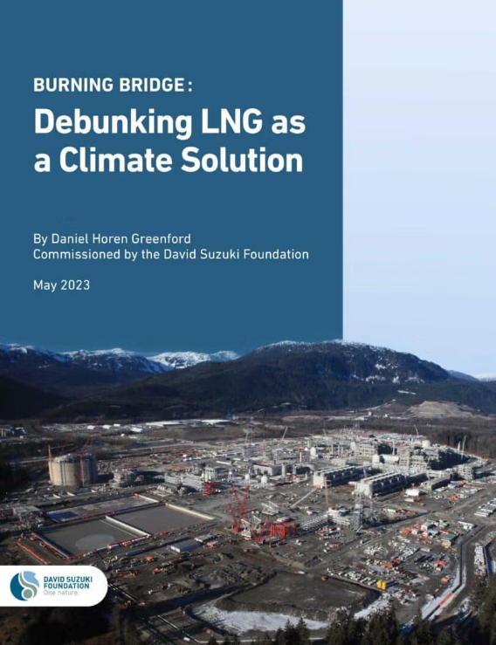
A breakdown of Eby’s pro-LNG talking points along with clear counter-arguments explaining why LNG is not a climate solution or good for B.C.’s economy:
B.C. Premier David Eby completes transition from LNG doubter with victory tour of Kitimat plant,

For a detailed analysis see the report: Canada’s Claims of “Low-Emission” LNG Are Not Accurate
Well-to-Tank Carbon Intensity of Canadian LNG and Buried Burdens: The True Costs of Liquified Natural Gas (LNG) Ownership

1. Talking Point: “LNG Canada is the largest private sector investment in Canadian history — it's about jobs and prosperity.”
Counter-Argument:
- Short-term jobs, long-term climate costs: Most LNG construction jobs are temporary. The majority of profits flow to multinational corporations, not local communities. Meanwhile, LNG projects lock in fossil fuel use for decades, undermining B.C.’s climate commitments.
- Opportunity cost: Every dollar invested in LNG is a dollar not invested in renewable energy, efficiency retrofits, and grid infrastructure — all of which create more jobs per dollar and are future-proof.
2. Talking Point: “LNG promotes Indigenous partnerships.”
Counter-Argument:
- While some First Nations have partnered with LNG projects, many First Nation leaders oppose them due to environmental risks, impacts on rights and title, and threats to salmon and traditional territories.
- True economic reconciliation means investing in Indigenous-led clean energy, not locking communities into fossil fuel infrastructure destined to become stranded assets as the world transitions quickly to clean energy.
3. Talking Point: “LNG helps Canada access Asian markets and reduce dependence on the U.S.”
Counter-Argument:
- Global LNG demand is volatile and declining: The IEA and other major analysts project a peak in fossil gas demand by 2030. Asian countries like Japan and South Korea are investing heavily in renewables and hydrogen, not long-term LNG deals.
- LNG markets are risky and oversupplied, increasing the chances that Canadian projects will become stranded assets.
4. Talking Point: “Canadian LNG is ‘responsibly produced’ and lower-carbon than other sources.”
Counter-Argument:
- LNG is still a fossil fuel: Even “low-carbon” LNG produces significant emissions from fracking, methane leakage, liquefaction, transport, and combustion. Methane is over 80 times more potent than CO₂ over 20 years.
- There’s no clean version of LNG. “Lower carbon than Qatar” is not a climate solution — it’s still adding to the problem.
5. Talking Point: “We’re helping other countries reduce emissions by replacing coal with LNG.”
Counter-Argument:
- The “coal-to-gas” switch is a myth: Studies show that LNG often displaces renewables, not just coal, especially in markets already transitioning. LNG can delay clean energy buildout.
- Lifecycle emissions of LNG (including methane leaks) can be as bad or worse than coal. The idea that LNG is “clean” is outdated and misleading.
6. Talking Point: “It’s better for Japan and Korea to buy LNG from Canada than from Qatar or the U.S.”
Counter-Argument:
- False choice: We don’t reduce global emissions by fighting over who gets to sell fossil fuels. The real goal is to accelerate clean energy adoption worldwide — not just offer a slightly cleaner version of the same problem.
- Longer shipping distances don’t negate LNG’s climate damage — they’re a minor part of total emissions compared to upstream extraction and combustion.
7. Talking Point: “LNG supports high-quality labour standards and environmental protections.”
Counter-Argument:
- These standards should apply to any project — including renewables. They don’t justify fossil fuel expansion.
- Worker transition plans and green jobs programs offer far more long-term stability than a boom-and-bust fossil fuel industry increasingly at risk from automation and global transition.
8. Talking Point: “LNG Canada’s emissions are 60% lower than the global average.”
Counter-Argument:
- That’s a PR stat with no climate credibility. Even 60% lower still means millions of tonnes of CO₂ and methane.
- What matters is absolute emissions reductions — and LNG Canada will still produce emissions incompatible with B.C.’s own climate targets under the CleanBC plan.
9. Talking Point: “Phasing out fossil fuels takes time — LNG is a necessary bridge.”
Counter-Argument:
- LNG is not a bridge, it’s a speedramp to more climate chaos. The world needs to cut emissions by nearly half this decade. Building new LNG infrastructure in 2025 that will operate until 2055 is reckless and counterproductive.
- Clean energy is now cheaper, faster to deploy, and more job-rich than fossil gas — and doesn’t threaten air and water.
10. Talking Point: “If we didn’t do this, Canada would miss out — others would build it anyway.”
Counter-Argument:
- Following others off a cliff is not leadership. B.C. has the potential to lead in renewable energy, conservation, and Indigenous-led solutions, not LNG exports.
- A “race to the bottom” logic justifies continued harm for profit — rather than investing in resilient, future-proof industries.

Well-to-Tank Carbon Intensity of Canadian LNG

Canada’s methane emissions for oil and gas activities reported in the Greenhouse Gas Reporting Program are 54% lower than satellite measurements.

• Projected Canadian methane emissions from liquefaction (3.48gCO2 e/MJ) are inconsistent with those reported by the US (12.55 gCO2 e/MJ) and other nations. Due to the absence of large-scale LNG facilities in Canada as of early 2025, Canadian estimates are mostly based on proposed low-carbon scenarios and not real world projections.
• Well-to-tank emissions (production, extraction, liquefaction, and transport) of Canadian LNG (28.58 gCO2 e/MJ, AR5 GWP100 ) are roughly the same as the average (e.g., 20.22 gCO2 e/MJ, AR5 GWP100 ) for EU Imports (Russia, Algeria, US, Nigeria, Qatar, UK, Trinidad and Tobago, Norway).
• Canadian LNG emissions projections are contingent on facilities powered by renewable electricity.
• Exporting Canadian LNG could significantly raise the fuel’s overall emissions, largely due to methane leaks during LNG tanker transport. Around 90% of the global LNG shipping fleet use low pressure dual fuel engines which produce 10 to 45x the amount of methane slip compared to readily available high pressure engines.

