MLA Meeting Toolkit
Updated February 2026

MLA Meeting Toolkit 1
Why are we meeting with MLAs? 1
Arranging a Meeting with MLAs 2
Step 1. Book your meeting 2
Step 2. Assemble your group 2
Step 3. Prepare your agenda 2
Step 4: Prepare your materials 4
Step 5. Call/email and confirm your meeting two days before 5
Step 6. Have the meeting (and get a photo) 5
Step 7. Report out 5
Step 8. Follow up 5
Common talking points we hear from MLAs, and how to respond 6
Appendix: Email template for booking MLA meeting 7

Why are we meeting with MLAs?
BC is moving in the wrong direction. The province’s emissions are going up steadily, driven by fossil fuel expansion, while other jurisdictions around the world are achieving major reductions. Pollution is worsening, the affordability crisis is deepening, and Indigenous rights are under attack.

BC’s climate plan, CleanBC, is not up to the challenge. It needs a major overhaul to meet the scale of the climate crisis.

The BCCEC’s 2025 Climate Action Progress Report assigned the BC government a failing grade on 8 of 10 urgent climate actions. 645+ groups have now signed on to these 10 actions, representing diverse sectors throughout BC.

We need the BC government to see this Report – and to take action.

Arranging a Meeting with MLAs

Step 1. Book your meeting
MLAs’ schedules are busy. Meetings are usually booked a few weeks out. Start trying to get a meeting now. You can prepare once the date is set.

Steps to book your meeting:
- Find your MLA’s email and phone contact information.
- Email your meeting request to the MLA (you can use the template email in the appendix below as a starting point).
- Follow up with a phone call if you don’t hear back in a few days.
- Repeat the email and phone call process as needed.

In person or online meetings are both great options, depending on your comfort levels and the MLA’s schedule.

NOTE: A 30 minute meeting is standard. You can see some potential time slots via the Parliamentary Calendar.

Step 2. Assemble your group
Your meeting will have more impact if you come with others. Note: as long as one person is a constituent, you may bring non-constituents with you.

Here are some suggested roles (you may not need every role, and one person may be able to do multiple roles):

Facilitator: The person who will lead the questions and transitions.
Note-taker: This is essential. Ideally it’s not the person facilitating.
Backup note-taker: If you have enough members.
Story-tellers: Every member, even if briefly, in that opening introduction round.
Time keeper: To politely nudge the facilitator on (could also be the note-taker’s job).

To make sure the meeting goes smoothly, we suggest doing a rehearsal with your group, so everyone can get comfortable with their roles.

Step 3. Prepare your agenda
This agenda is designed for you to have a respectful and meaningful meeting with your MLA.

You might want to copy-paste it into a new document, and edit it so that it feels natural and comfortable for you.

TIP: Take some time to research your MLA. Look at their social media accounts. What is their background? What do they care about? Have they expressed support for climate action in the past? Framing your asks in relation to their interests goes a long way.

SAMPLE AGENDA (30 minutes)
 | Opening  (3 min) | Thank you for the meeting.  We would like to introduce ourselves and talk to you about the province’s climate ambition.  We will be sure to keep to time.  We are here because we care about our province, and we know that our democracy relies on a partnership between us, your constituents, and you, our representative.  We want to recognize [something your MLA has said or done in the past that you can praise and give positive feedback on - or some positive climate progress BC has made in the last year.]
 | Make yourselves memorable  (5 min) | Go around. Each person shares:  -Name  -Organizational affiliations  -What about the climate crisis is most painful or urgent for you right now? (keep it short)  Ask the MLA to answer, too.
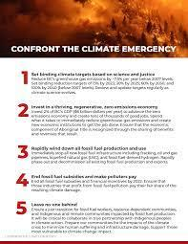 | Educate (5 min) | We are here to talk to you about the latest Climate Action Progress Report released by the BC Climate Emergency Campaign (TIP: if you are meeting in person, bring a physical copy with you and leave it there).  (Next, we suggest you share the following):  - The overall grades (pg. 14-15 of the report). Note that these are the worst grades given since the reports started in 2022)  - Key takeaways (pg. 7)  - “Ways to finance climate solutions” (pg. 8)  645+ organizations and businesses from diverse sectors have signed on to these 10 urgent climate actions, representing 2.2 million British Columbians. People in BC still care about climate change, even if other issues are currently taking precedent.  [TIP: If you are meeting to discuss a specific action, focus on the grade assigned to that action, sharing the detailed data from experts on each action, explaining why it received the grade it did.]
 | Ask questions (5 min) | Can you tell us about any internal dynamics or pressures within government that are leading to this rampant fossil fuel expansion?  Are you aware of the risks that come with BC’s LNG expansion? (i.e. health risks, lack of jobs, rising electricity bills, greenwashing LNG, increased pollution)  What opportunities are coming up where we can support the BC government in bringing in bolder climate action?
 | Ask for a commitment (5 min) | Can you agree to take this topic to your colleagues in caucus?  (or a question that feels more fitting, given the topic and your MLA)
 | Thank you & follow-up  (3 min) | Thank you so much.  Would we be able to meet with you again in a few months, possibly with other constituents who couldn’t attend this time?

Step 4: Prepare your materials
If you are having a virtual meeting, be ready to share a link to the 2025 Progress Report.

If you are meeting in person, we recommend you bring a physical copy of the report. Email Tracey at tracey@myseatosky.org to receive one.

Step 5. Call/email and confirm your meeting two days before
Two days before your meeting, give the MLA’s office a call or send an email to confirm the meeting, and let them know the numbers of people attending.

Establishing positive relationships with constituency staff can make a big difference in getting future meetings.

Step 6. Have the meeting (and get a photo)
Meet with your group at least 15 minutes prior to your meeting. Ensure you have your materials ready, and everyone knows their roles.

Reminders:
- It’s normal to feel nervous! Remember, you are a concerned constituent, not a climate expert or a professional lobbyist. The most important thing you need to do is speak from the heart and show you care.
- Think of this also as the beginning of a long-term relationship. It’s these relationships that make representatives feel their accountability.
- Please take a photo of your group and the MLA - if the meeting is virtual you can take a screenshot.

Step 7. Report out
Discuss as a group: how would we evaluate that meeting? How did the MLA respond? Did we achieve our aims? Anything we would do differently next time?

Get the note takers to digitize their notes while they are fresh, then send them to coordinator@bcclimateemergency.ca.

This intel is very helpful, and by sharing it promptly with us we can take what you’ve learned and feed it into our strategy.

Step 8. Follow up
Thank the Constituency Assistant by email and make sure you get that second meeting on the calendar. Share any resources or educational materials you mentioned during the meeting.

Common talking points we hear from MLAs, and how to respond

BC is broke. This is a period of austerity. We aren’t able to fund climate solutions.

There are a number of ways the government could fund climate solutions, including:
- taxing the ultra wealthy
- taxing big polluters
- increasing royalty rates for fossil fuels and water
- ending fossil fuel subsidies

If this is truly a period of austerity, the BC government should not be handing out millions to fossil fuel companies. This is not a question of whether the money exists, it is a question of whether the government wants to continue subsidizing the companies fueling the flames of climate chaos or fund climate solutions.

British Columbians aren’t concerned about climate change anymore. We have to focus on other priorities.

That’s why I am here. I am a constituent who is concerned about the climate. The BC Climate Emergency Campaign has 645+ organizational signatories representing 2.2 million British Columbians. I know that British Columbians are struggling with many pressing issues like housing, affordability, and healthcare. But these issues are interconnected. Many of the causes and solutions to these issues are the same as the causes and solutions to the climate crisis.

For example, BC could make heat pumps free and incentivize energy retrofits for buildings. Pass legislation to stop new gas hookups in buildings. This will reduce pollution, save lives, and improve affordability by lowering energy bills.

Abacus Data polling shows 75% of Canadians are concerned about climate change (see below).

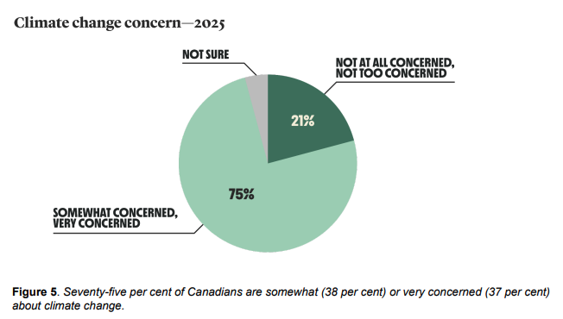

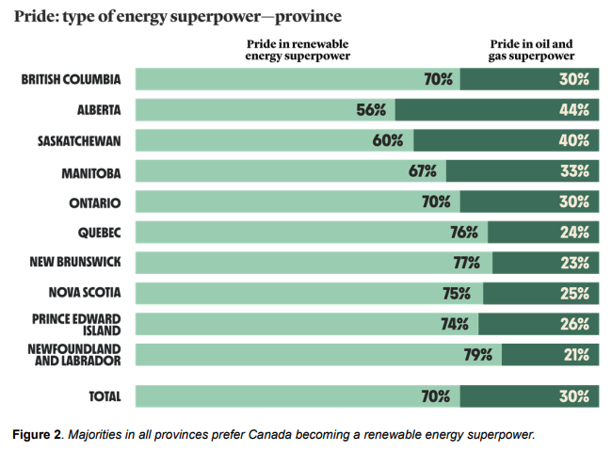
Also, 70% of British Columbians - a clear majority - would prefer Canada to be a renewable energy superpower, rather than an oil and gas superpower.

BC’s LNG is the cleanest in the world.

LNG is a fossil fuel. Even if it’s claimed to be “low-carbon” because the liquefaction process is fueled through electrification, the entire life cycle of LNG (fracking, transport, regasification, combustion) must be taken into account. Methane leaks at every point along the life cycle, and is a potent fossil fuel, over 80 times more potent than CO₂ over 20 years.

Even if BC’s LNG is supposedly “60% lower than the global average,” that’s still millions of tons of pollution entering the atmosphere.

Other countries, like India and China, need BC’s LNG to get off coal.

This is a myth. Studies show that LNG is not displacing coal, but crowding out and delaying renewable energy buildout.

When considering the entire lifecycle of LNG, including methane leaks, LNG is actually as bad as coal, or worse.

BC’s LNG projects are Indigenous-led, and will help these communities prosper.
While some First Nations have partnered with LNG projects, many First Nation leaders oppose them due to environmental risks, impacts on rights and title, and threats to salmon and traditional territories.

True economic reconciliation means investing in Indigenous-led clean energy, not locking communities into fossil fuel infrastructure destined to become stranded assets as the world transitions quickly to clean energy.

Check out more LNG-related talking points here.

Appendix: Email template for booking MLA meeting
Email template

Subject line: Constituent meeting request to discuss 2025 Climate Action Progress Report

Dear (MLA’s name),

I would like to arrange a meeting with you to discuss the BC government’s response to the climate emergency – an issue of importance to myself and other constituents in your riding. I am a constituent and live in (insert your neighbourhood).

The BC Climate Emergency Campaign just released its 2025 Climate Action Progress Report evaluating the provincial government on its progress in relation to 10 urgent actions. This is a crucial resource as it lays out where the government has made improvements, and where greater work is needed.

(Add a sentence or two about why the climate emergency matters to you personally)

I know you have a busy schedule, so please let me know a date and time that works for you in the coming weeks. I look forward to hearing from you.

Thank you,
(your name)
(your contact phone number)

Phone script

Hello. My name is (your name) and I am a resident of (riding name). I sent an email requesting a meeting and wanted to follow up with you to arrange a date and time. Could you help me get a meeting scheduled?

Leave a message if there is no answer - these will be processed and forwarded to the appropriate staff member. Be sure to leave your phone number and email address in the message!

